Azure Deployment of Web API with EF, SQL Server

Create a Web API
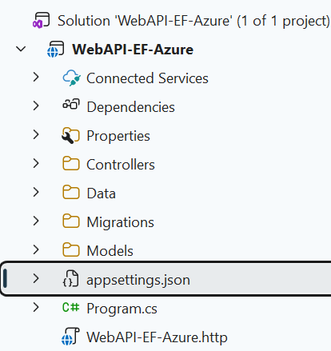

🔷 Azure Demo Lab: Web API + SQL Server + EF Core
🧱 Architecture Overview
- Backend: ASP.NET Core Web API
- ORM: Entity Framework Core
- Database: Azure SQL Database
- Hosting: Azure App Service
- CI/CD (optional): GitHub Actions

🔶 PART 1: Create Azure SQL Database
Steps (Portal)
- Go to Azure Portal → SQL Databases → Create
- Configure:
  - Resource Group: rg-api-demo
  - Database Name: db-product
  - Server: Create new (username/password)
- Compute:
  - Use Basic / Serverless (for demo cost control)
- Networking:
  - Allow Azure services + your IP
After Creation
- Copy Connection String from:
→ Settings → Connection Strings

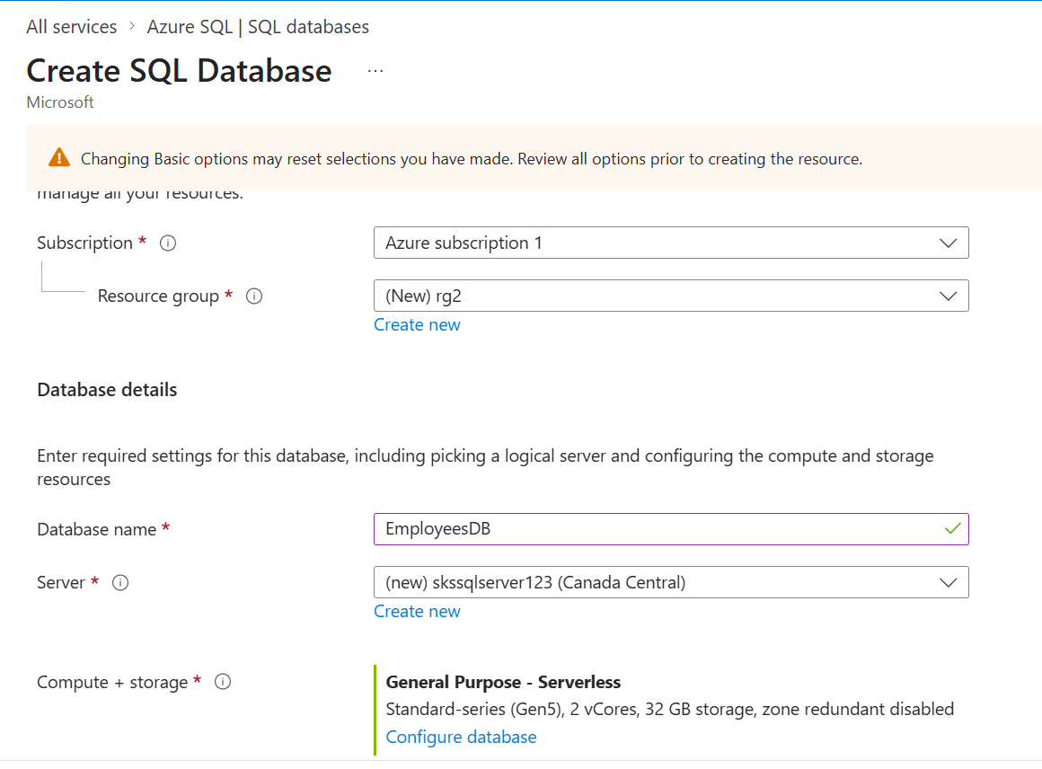
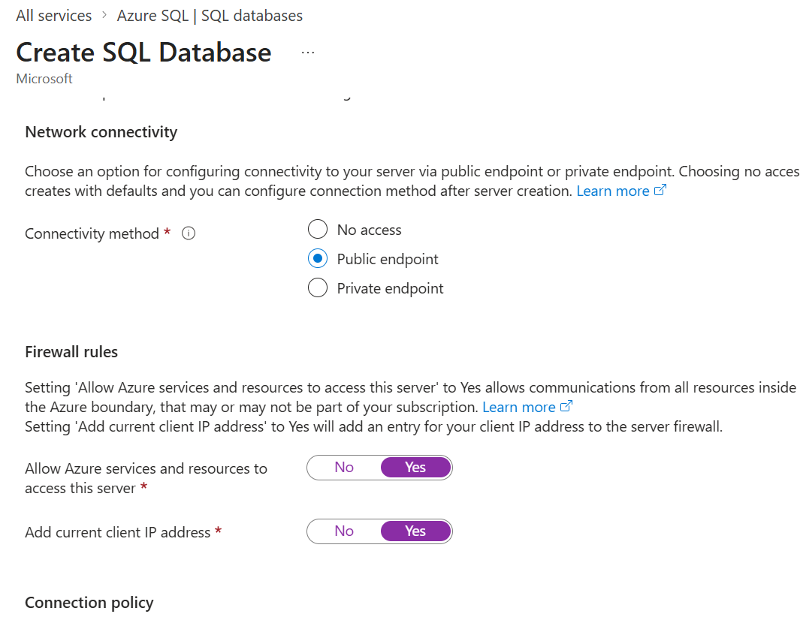
Create new SQL Server with uid and pwd

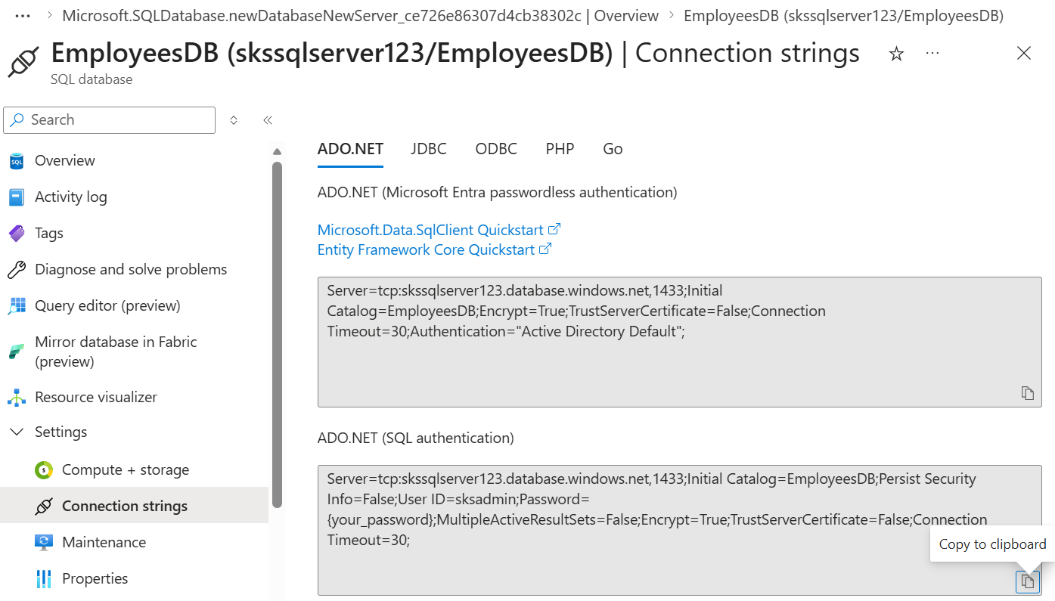

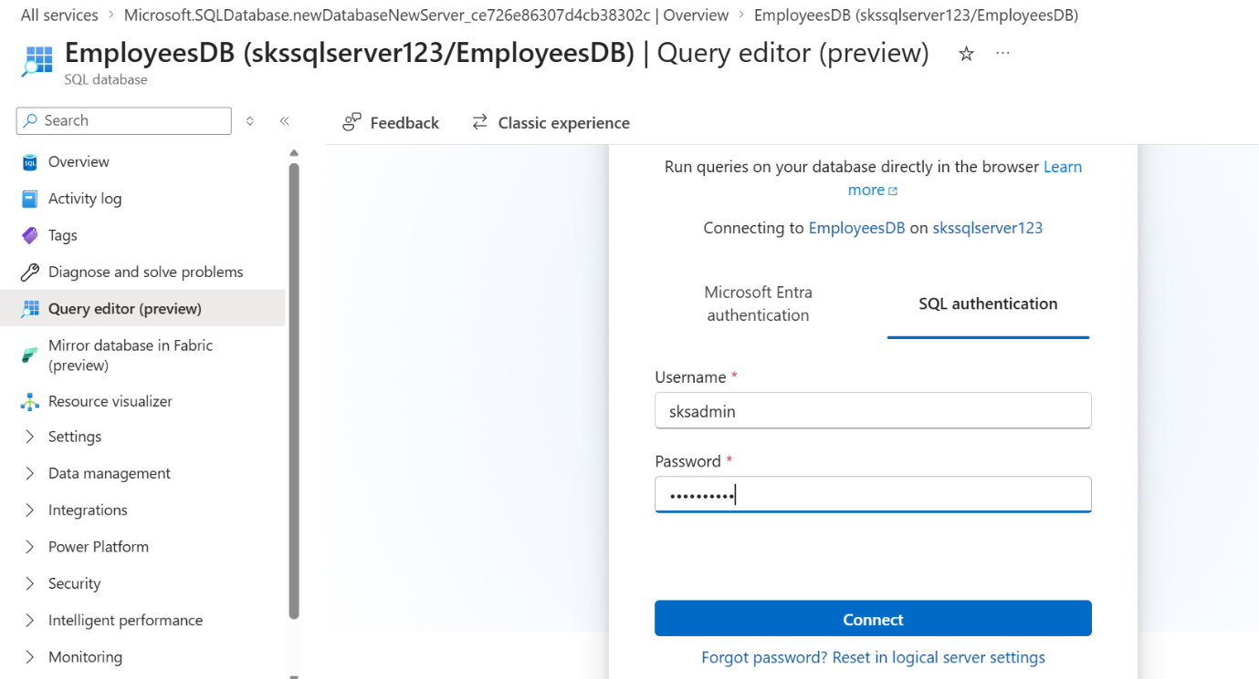

Server=tcp:skssqlserver123.database.windows.net,1433;Initial Catalog=EmployeesDB;Persist Security Info=False;User ID=sksadmin;Password=Sharad@123;MultipleActiveResultSets=False;Encrypt=True;TrustServerCertificate=False;Connection Timeout=30;

🔶 PART 2: Create ASP.NET Core Web API
In Visual Studio:
- Create project:
  - ASP.NET Core Web API
  - .NET 6/7/8
- Install NuGet packages:
Microsoft.EntityFrameworkCore.SqlServer
Microsoft.EntityFrameworkCore.Tools

🔷 Create Model

🔷 Create DbContext

🔷 Configure Connection (appsettings.json)
"ConnectionStrings": {
"DefaultConnection": "YOUR_AZURE_SQL_CONNECTION_STRING"
}

🔷 Register in Program.cs
builder.Services.AddDbContext<AppDbContext>(options =>
options.UseSqlServer(builder.Configuration.GetConnectionString("DefaultConnection")));

🔶 PART 3: Apply Entity Framework Migration
Run in Package Manager Console:
Add-Migration InitialCreate
Update-Database
✔ This creates tables in Azure SQL

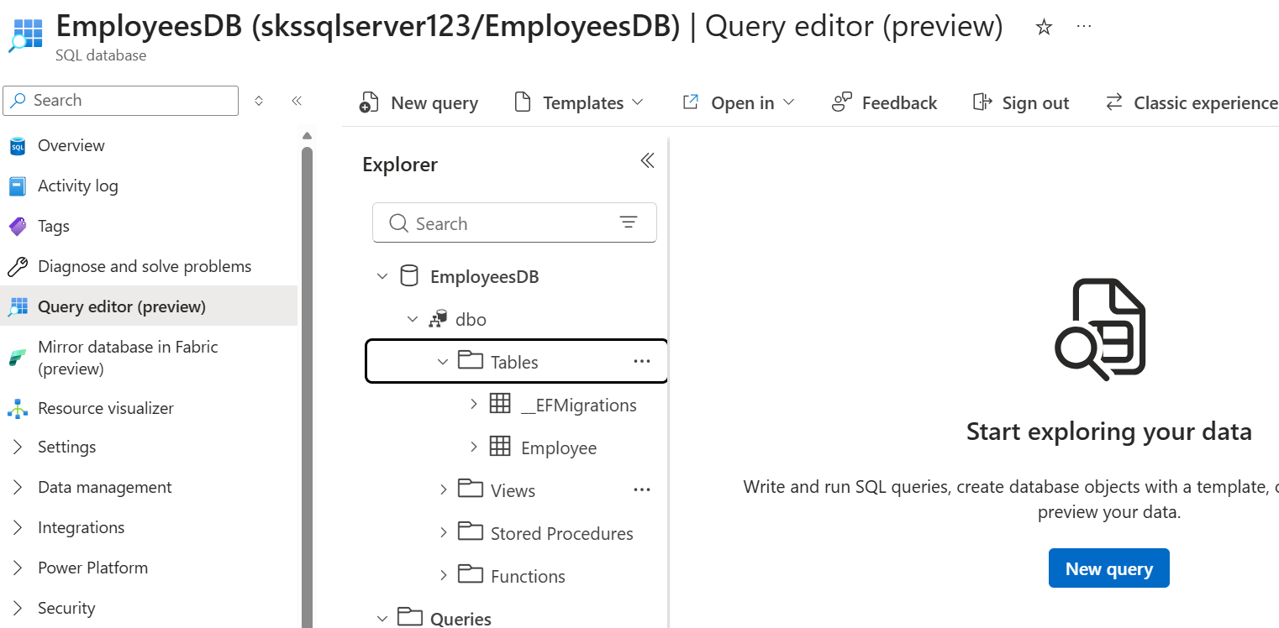

🔶 PART 4: Create Controller

🔶 PART 5: Create Azure App Service
Steps
- Go to App Services → Create
- Configure:
  - Name: api-demo-app
  - Runtime: .NET
  - OS: Windows/Linux
- Pricing Tier:
  - Use F1 (Free) or B1

🔶 PART 6: Publish Web API to Azure
From Visual Studio:
- Right-click project → Publish
- Choose:
  - Azure → App Service
- Select created App Service
- Click Publish

🔶 PART 7: Configure Connection String in Azure
⚠️ IMPORTANT (Production best practice)
- Go to App Service
- Settings → Configuration → Connection Strings
- Add:
  - Name: DefaultConnection
  - Value: Azure SQL connection string
  - Type: SQLAzure
✔ Overrides local config securely

🔶 PART 8: Test API
Use:
- Browser → https://yourapp.azurewebsites.net/api/products
- Or Postman

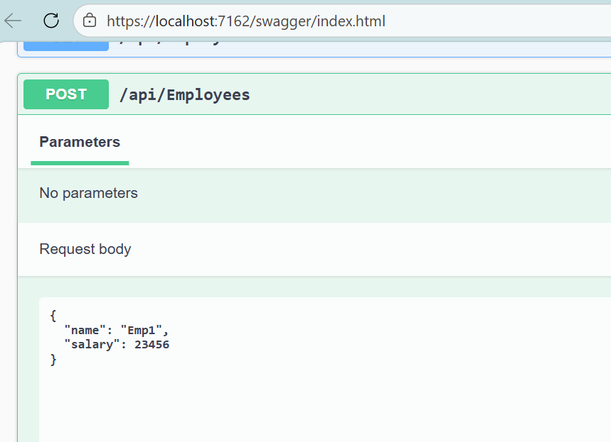
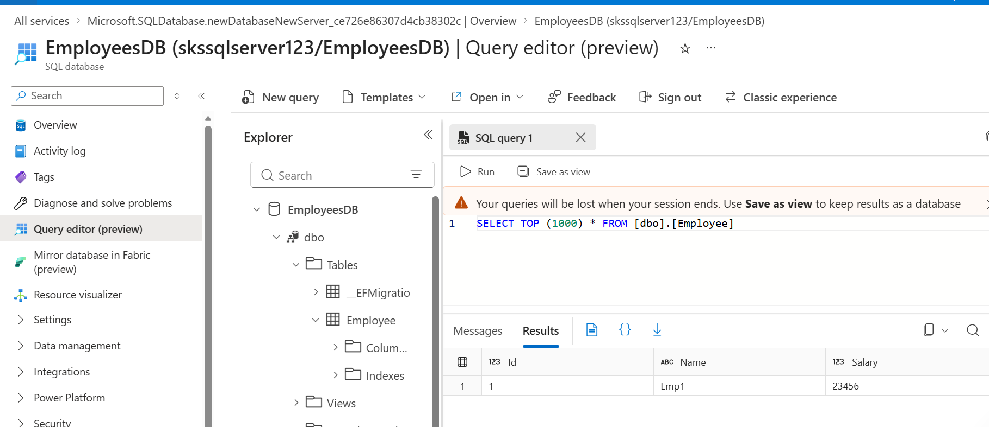

🔶 PART 9: Enable Auto Deployment (CI/CD)
Using GitHub Actions:
Steps
- Push code to GitHub
- In Azure App Service:
  - Deployment Center → GitHub
- Configure workflow
✔ Auto deploy on every commit

🔶 OPTIONAL ENHANCEMENTS
🔹 1. Add Swagger
builder.Services.AddEndpointsApiExplorer();
builder.Services.AddSwaggerGen();

🔹 2. Secure API
- Add API Key / JWT
- Or integrate with Azure API Management

🔹 3. Use Managed Identity (Advanced)
- Avoid storing connection string credentials
- Use Azure AD authentication for SQL

🔷 Common Issues (Important for Demo)
❌ Cannot connect to SQL
✔ Fix:
- Enable "Allow Azure services"
- Add client IP in firewall

❌ EF Migration fails
✔ Fix:
- Ensure correct connection string
- Use TrustServerCertificate=True

❌ API works locally but not on Azure
✔ Fix:
- Move connection string to App Service config

Never keep the database password in your source code or appsettings.json for production. Use Azure-managed configuration or identity-based access.
Here are the correct, production-grade options (ranked):

🔐 ✅ 1. Azure App Service Configuration (Recommended baseline)
When hosting on Azure App Service:
Where to store
- App Service → Settings → Environment Variables (Configuration)
What to do
- Add:
  - Name: ConnectionStrings__DefaultConnection
  - Value: your full connection string
✔ Stored securely (encrypted at rest)
✔ Not in code
✔ Automatically injected at runtime
Why it works
ASP.NET Core automatically maps:
ConnectionStrings__DefaultConnection
→ Configuration.GetConnectionString("DefaultConnection")

🔐 ✅ 2. Azure Key Vault (Best practice for security)
Use Azure Key Vault
Flow
- Store secret in Key Vault:
  - Name: DbConnectionString
- Enable Managed Identity on App Service
- Grant access to Key Vault (Access Policy / RBAC)
- Reference secret in App Service config:
@Microsoft.KeyVault(SecretUri=https://<vault-name>.vault.azure.net/secrets/DbConnectionString)
✔ No secrets stored anywhere in app or config
✔ Centralized secret rotation
✔ Enterprise-grade security

